LAB Logbook

Github - https://github.com/Shamoonmalik/Machine-Learning-in-Finance

Lab 1 -

Lab 2 –

Lab 3-

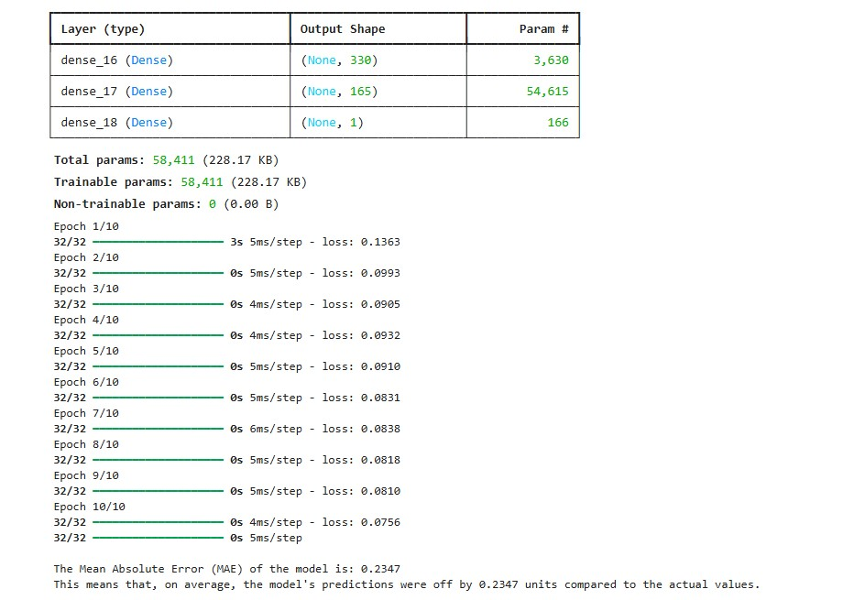

Lab 5 –

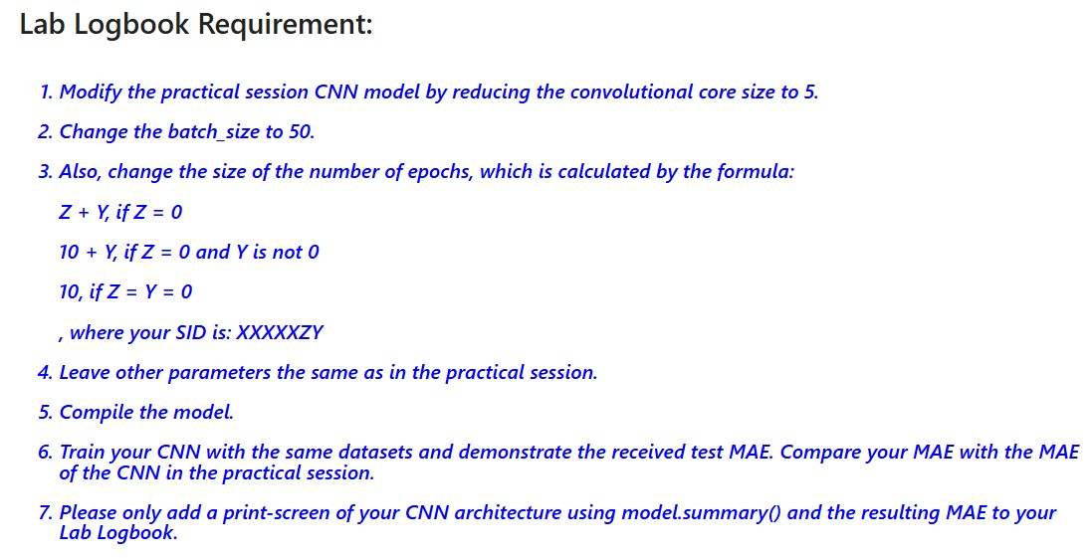

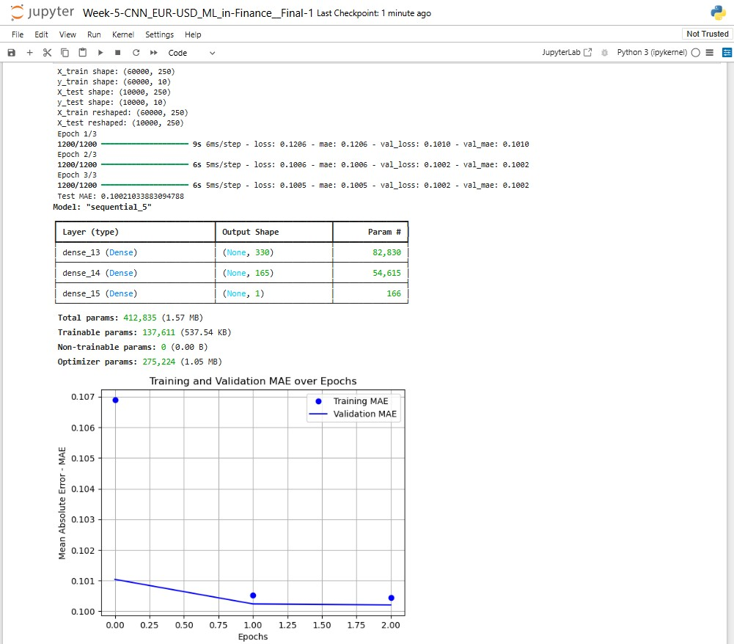

Lab 6

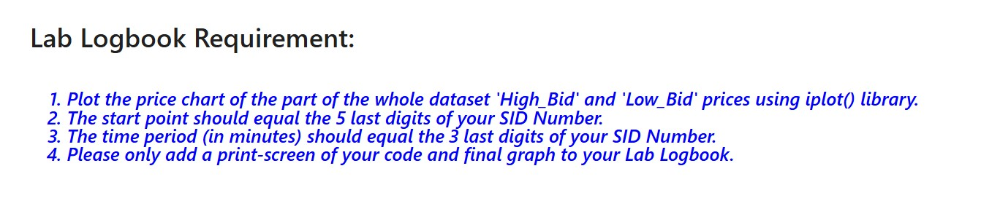

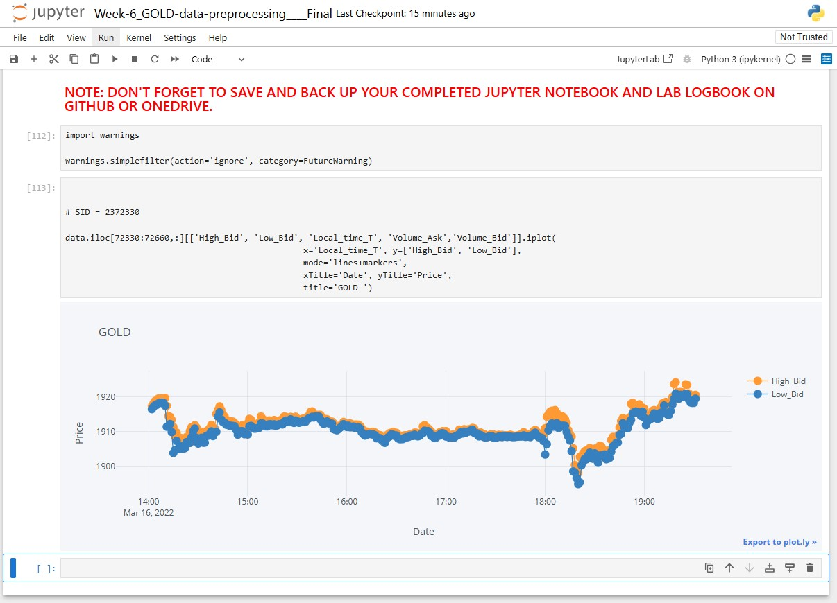

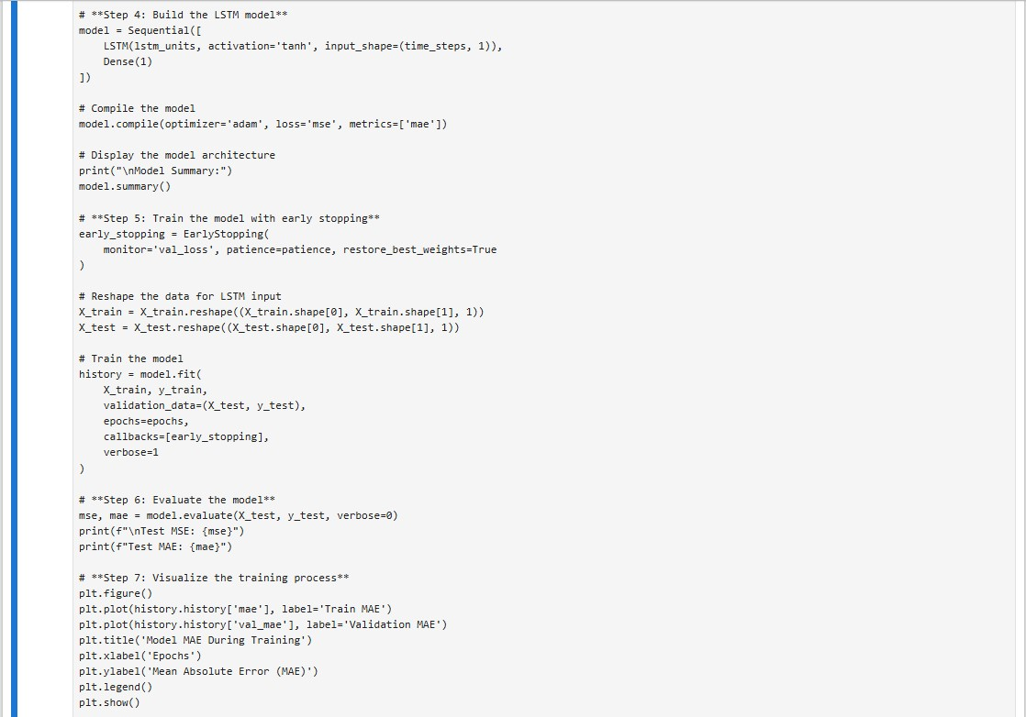

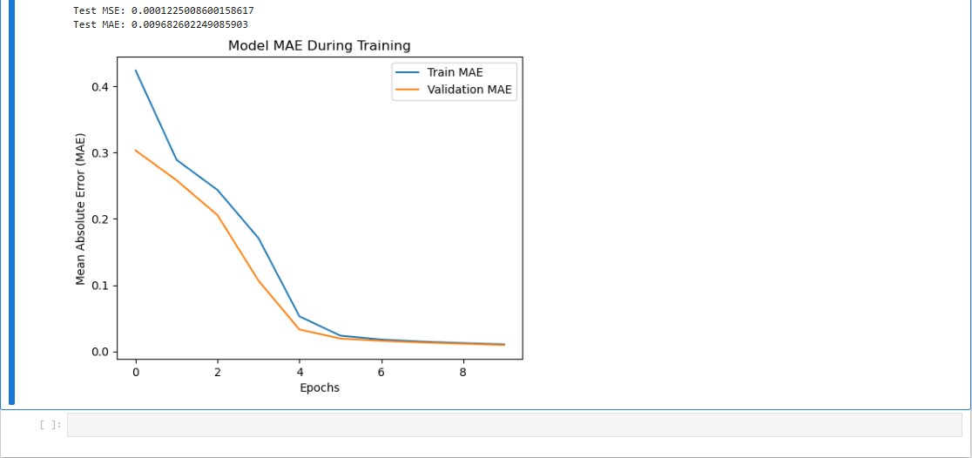

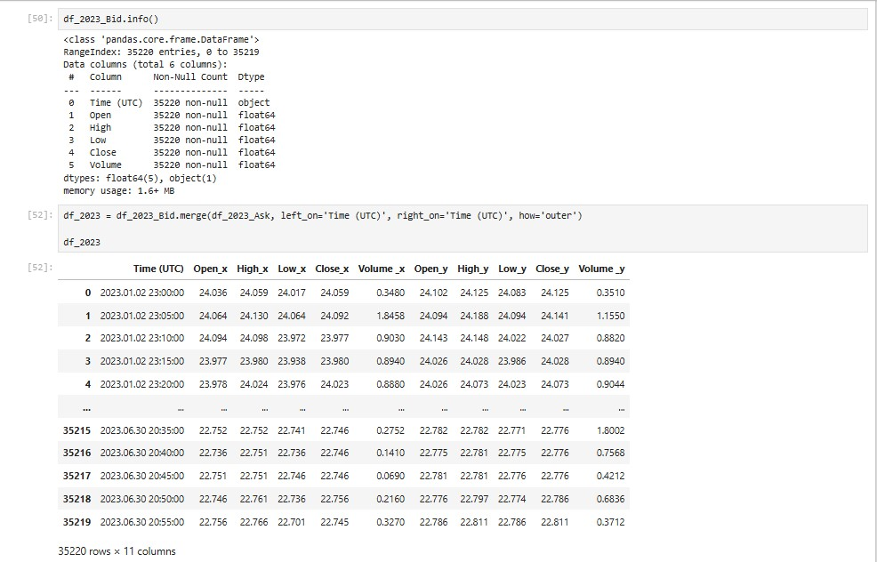

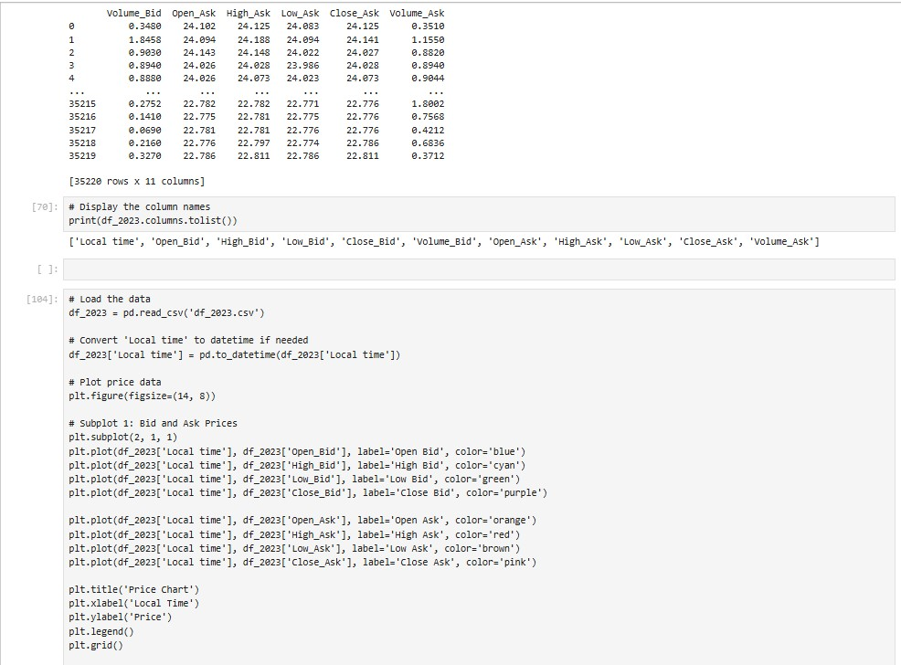

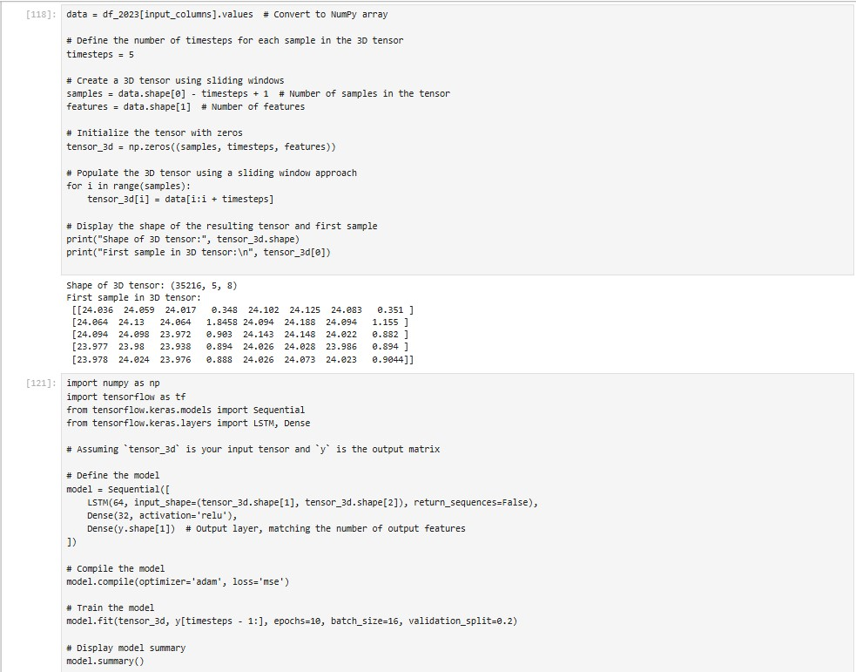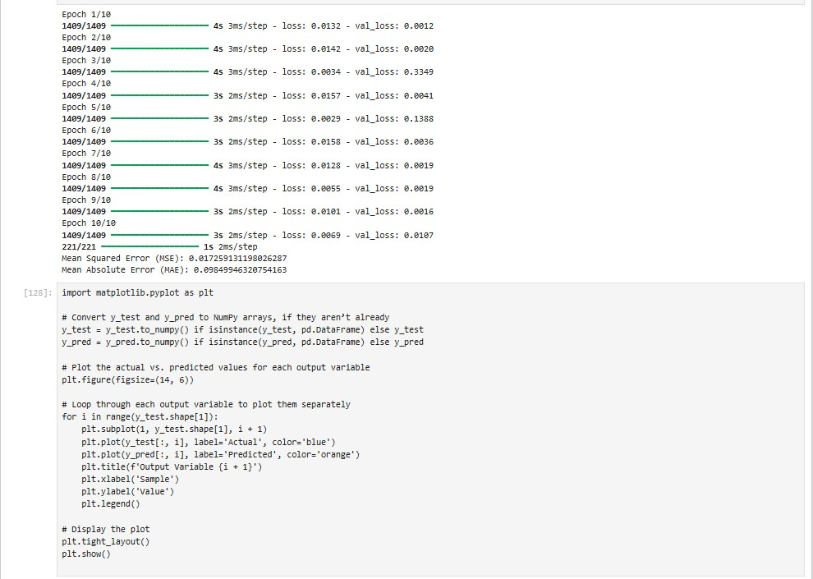

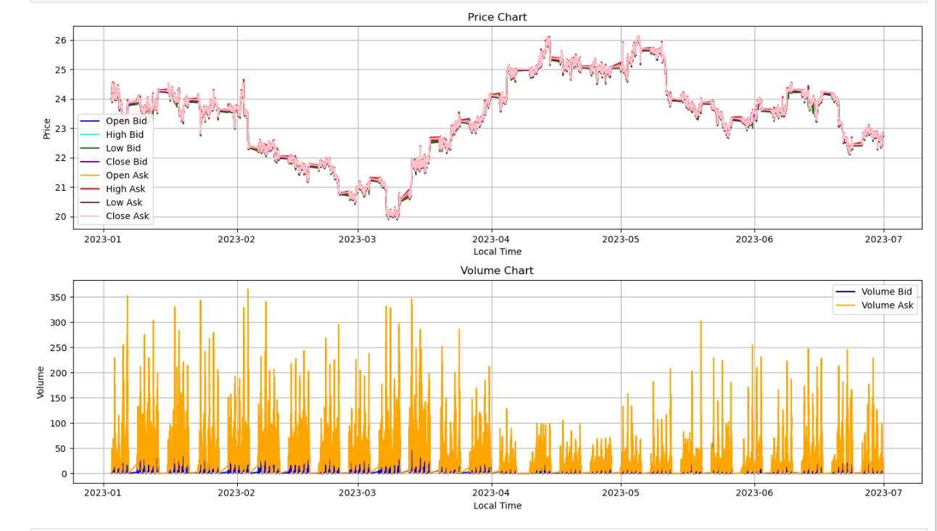

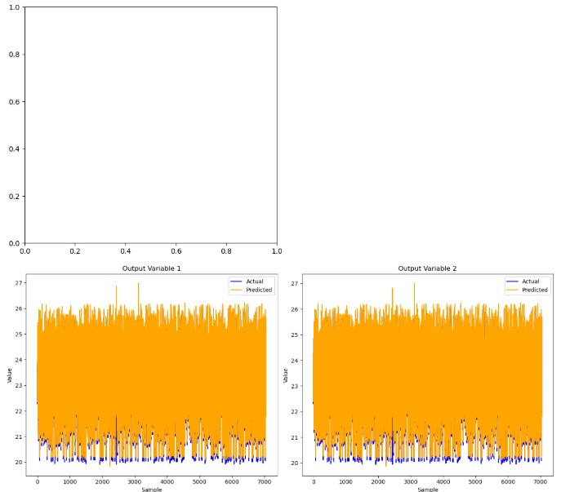

Lab 9 – Class Test

Lab 12